Paper 2 for EN110—(2-3 pages) “Fake News” and Knowing How to Find the Truth (Due February 21)

It’s safe to say that the 2016 Presidential Election was one of the most partisan and divisive in the nation’s history. Also, it will likely have long-term implications on the future of the country and how the United States and other nations interact. The spread of fake news stories and the way Americans consume media often make it difficult to know what’s real and what’s not.

To remain informed and active citizens in a democracy, it will be imperative to be more discerning about the information we receive and to not discredit viable news just because it does not match our political persuasion. Despite receiving regular criticism in the national press, Thomas Jefferson recognized the necessity of having a free press and sought to protect it to ensure democratic mechanisms continued to operate in the best interest of the people. Don’t just be a cog in the system; think for yourself!

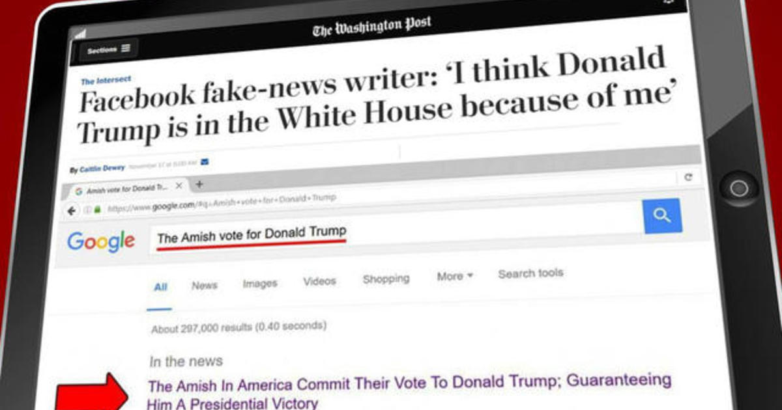

Read and identify the tell-tale signs of the following fake news article. Be sure to clearly define what constitutes fake news, why it’s a problem for a functioning democracy, how one can avoid being misled and misinformed, and why it is so dangerous to use the term “fake news” too broadly. (You will need a minimum of 3 sources, the article counts as one).

https://archive.is/49jlQ

Learning Objectives: You should be able to identify quality academic sources of information and incorporate or refute them in an articulate manner in writing. Also, you should be able to organize an essay response that is complex and fully explains the concepts.

Why it should matter to you. *Your ability to be able to pick apart and respond to reading will be an invaluable tool as a researcher. You will benefit in writing your capstone and in sharing information at work if you can be sure that the information being used as support is reputable. The key to establishing your credibility as a writer can be dramatically compromised if you are not able to master these skills.*

